Apply the STAR method during interviews

You’ve been learning about different techniques and strategies to use during future interviews for jobs in the cybersecurity field. In this reading, you’ll learn more details about the STAR method for answering interview questions. Implementing this strategy will help you answer interview questions with confidence and clarity.

**The STAR method**

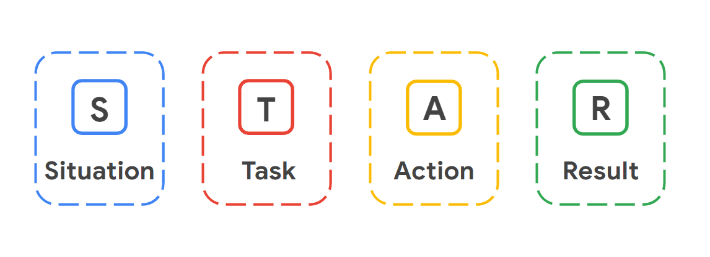

When interviewing for a job, it can be challenging to convey the right details about your professional history and skills to your interviewers. Using the STAR method can help you share your success stories effectively and strategically. STAR stands for Situation, Task, Action, and Result. Using this method enables you to describe potential challenges you faced in previous roles and gives you the opportunity to show how you thoughtfully approached solving those problems from start to finish.

**Situation**

The **situation** is the project you worked on or a challenge that you had to overcome. For example, perhaps you had to manage a disgruntled customer’s negative feedback about your company,  a system error on your work device that slowed down a customer transaction, or being left alone in the office for an extended period of time. Fully describing the situation allows the interviewer to gain a clear understanding of the challenge you had to overcome.

**Task**

The **task** outlines the key responsibilities or role you played in solving the challenge described in the situation phase of the STAR method. Specifying what the task is provides clarity about what your objectives were in this scenario.

**Action**

The **action** describesthe exact steps you took to resolve the challenging situation you described in the beginning of the STAR method. The action is crucial to the STAR method because it allows the employer to understand what choices you made to achieve your desired outcome during a real conflict or challenge. Employers want employees who can think fast and make decisions that help solve problems.

**Result**

Finally, sharing the **result** of your challenge or example shows the employers how the situation was resolved as a direct result of the actions you took. When participating in an interview, you want to make sure that any example you give with the STAR method ends in a positive result. Positive results show an employer that you are someone who has demonstrated an ability to successfully resolve issues and may lead an employer to offer you a job. Of course, not all situations have completely positive outcomes; if an employer asks you about a situation that didn’t have a positive outcome, try to focus on what you learned from the situation and how that experience helped you become a better employee.

**Key takeaways**

The STAR method stands for Situation, Task, Action, and Result. Following this method helps you communicate to an employer an example of a challenge you faced in the workplace. Remember to use one of your success stories when using the STAR method on an interview. Challenges arise all the time in the security world, so being able to demonstrate an ability to overcome any type of challenge is a great trait to show off during an interview. Plus, since cybersecurity is such a team-driven industry, being able to communicate effectively to an interviewer will help you be a competitive applicant.